John Michael Go
Career Entry Level Java Programming
Date: Jan. 22, 2013

DAY 8

Program Name: Assign4

Objective: This is a program that sorts even an odd numbers between 1 to 10.

Algorithm:

1. Program outputs even an odd numbers between 1 to 10.

Flowchart:
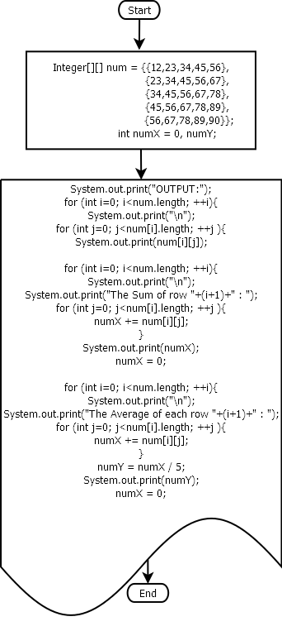

Pseudocode:

import java.util.Arrays;

public class Assign4{

public static void main(String[] args){
// array
Integer[][] num = {{12,23,34,45,56},
{23,34,45,56,67},
{34,45,56,67,78},
{45,56,67,78,89},
{56,67,78,89,90}};
int numX = 0, numY; // variable declaration
// Loop for displaying array
System.out.print("OUTPUT:");
for (int i=0; i<num.length; ++i){

System.out.print("\n");

for (int j=0; j<num[i].length; ++j ){

System.out.print(num[i][j]);
System.out.print(" ");

}

}

System.out.print("\n");
// Loop for adding the values in a row
for (int i=0; i<num.length; ++i){
System.out.print("\n");
System.out.print("The Sum of row "+(i+1)+" : ");

for (int j=0; j<num[i].length; ++j ){

numX += num[i][j];

}

System.out.print(numX);
numX = 0;

}

System.out.print("\n");
// Loop for computing the average of each row
for (int i=0; i<num.length; ++i){
System.out.print("\n");
System.out.print("The Average of each row "+(i+1)+" : ");

for (int j=0; j<num[i].length; ++j ){

numX += num[i][j];

}

numY = numX / 5;
System.out.print(numY);
numX = 0;

}

} // end static

} // end class

Screenshots:

